**JAVA ASSIGNMENTS**

1. **Write a program to cover all Java OOPS concepts. Topics need to cover:** 
   1. **Class and Object**
   2. **Class constructor**
   3. **Polymorphism**
   4. **Method overloading**
   5. **Method overriding**
   6. **Inheritance**
   7. **Interface**
   8. **Abstract class**
   9. **Abstraction and Encapsulation**
   10. **Composition and Aggregation**
   11. **Generalization and Specialization**

**Code:**

// Class and Object

class Animal {

// Encapsulation: Private fields and public access getter/setter methods

private String name;

private int age;

// Constructor

public Animal(String name, int age) {

this.name = name;

this.age = age;

}

// Getter and Setter method

public String getName() {

return name;

}

public void setName(String name) {

this.name = name;

}

// Getter and Setter for age

public int getAge() {

return age;

}

public void setAge(int age) {

this.age = age;

}

// Method to display details ----Abstraction

public void displayDetails() {

System.out.println("Name: " + name + ", Age: " + age);

}

}

//Polymorphism

interface Behavior {

void makeSound(); // Abstract method

}

class Dog extends Animal implements Behavior {

public Dog(String name, int age) {

super(name, age);

}

//Method overriding

@Override

public void displayDetails() {

System.out.println("Dog Name: " + getName() + ", Age: " + getAge());

}

//Method implementation from interface

@Override

public void makeSound() {

System.out.println("Woof Woof!");

}

}

class Cat extends Animal implements Behavior {

public Cat(String name, int age) {

super(name, age);

}

// Method overriding

@Override

public void displayDetails() {

System.out.println("Cat Name: " + getName() + ", Age: " + getAge());

}

// Concept: Method implementation from interface

@Override

public void makeSound() {

System.out.println("Meow Meow!");

}

}

//Abstract Class

abstract class Vehicle {

abstract void startEngine(); //Abstract method

public void displayType() {

System.out.println("This is a vehicle.");

}

}

class Car extends Vehicle {

@Override

void startEngine() {

System.out.println("Car engine started.");

}

}

// Composition and Aggregation

class Garage {

private Car car; // Aggregation

public Garage(Car car) {

this.car = car;

}

public void parkCar() {

System.out.println("Parking the car in the garage.");

car.startEngine();

}

}

// Generalization and Specialization

class SportsCar extends Car { // Specialization

@Override

void startEngine() {

System.out.println("Sports car engine roars to life!");

}

}

public class Main {

public static void main(String[] args) {

// Creating objects of Animal class

Dog dog = new Dog("Buddy", 3);

Cat cat = new Cat("Whiskers", 2);

//polymorphism and method overriding

dog.displayDetails();

cat.displayDetails();

//polymorphism through interface

Behavior[] animals = {dog, cat};

for (Behavior animal : animals) {

animal.makeSound();

}

//abstract class

Vehicle myCar = new Car();

myCar.startEngine();

myCar.displayType();

//composition and aggregation

Garage garage = new Garage(new SportsCar());

garage.parkCar();

//specialization

SportsCar sportsCar = new SportsCar();

sportsCar.startEngine();

}

}

**Output:**

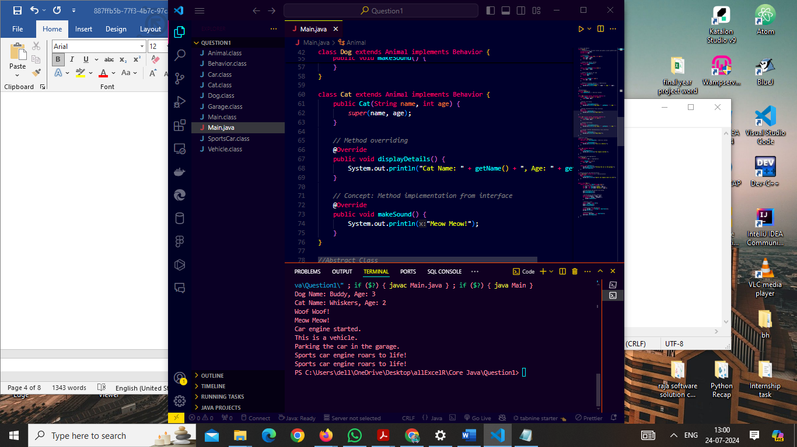

1. **Design a Java program that performs various string operations and uses control statements for user input validation. The program should allow the user to perform the following operations:**
   1. **Concatenate Strings: The user can enter two strings and the program should concatenate them.**
   2. **Find Length of a String: The user can enter a string, and the program should display its length.**
   3. **Convert to Uppercase and Lowercase: The user can enter a string, and the program should display it in both uppercase and lowercase.**
   4. **Extract Substring: The user can enter a string and specify the starting and ending index, and the program should extract and display the substring.**
   5. **Split a Sentence: The user can enter a sentence, and the program should split it into words and display them.**
   6. **Reverse a String: The user can enter a string, and the program should reverse and display it.**
   7. **Requirements:**
      1. **Use control statements (if-else, switch, loops) for input validation and handling possible errors.**
      2. **Implement a user-friendly console interface for the user to interact with the program.**
      3. **Cover all string concepts, such as concatenation, length, uppercase and lowercase conversion, substring extraction, splitting, and reversal.**

**Code:**

**import java.util.Scanner;**

**public class StringOperation {**

**public static void main(String[] args) {**

**Scanner scanner = new Scanner(System.in);**

**int choice;**

**do {**

**System.out.println("String Operations Menu:");**

**System.out.println("1. Concatenate Strings");**

**System.out.println("2. Find Length of a String");**

**System.out.println("3. Convert to Uppercase and Lowercase");**

**System.out.println("4. Extract Substring");**

**System.out.println("5. Split a Sentence");**

**System.out.println("6. Reverse a String");**

**System.out.println("0. Exit");**

**System.out.print("Enter your choice: ");**

**while (!scanner.hasNextInt()) {**

**System.out.println("Invalid input. Please enter a number.");**

**scanner.next();**

**System.out.print("Enter your choice: ");**

**}**

**choice = scanner.nextInt();**

**scanner.nextLine();**

**switch (choice) {**

**case 1:**

**System.out.print("Enter the first string: ");**

**String str1 = scanner.nextLine();**

**System.out.print("Enter the second string: ");**

**String str2 = scanner.nextLine();**

**System.out.println("Concatenated String: " + str1 + str2);**

**break;**

**case 2:**

**System.out.print("Enter a string: ");**

**String strLength = scanner.nextLine();**

**System.out.println("Length of the string: " + strLength.length());**

**break;**

**case 3:**

**System.out.print("Enter a string: ");**

**String strCase = scanner.nextLine();**

**System.out.println("Uppercase: " + strCase.toUpperCase());**

**System.out.println("Lowercase: " + strCase.toLowerCase());**

**break;**

**case 4:**

**System.out.print("Enter a string: ");**

**String strSubstring = scanner.nextLine();**

**System.out.print("Enter starting index: ");**

**while (!scanner.hasNextInt()) {**

**System.out.println("Invalid input. Please enter a number.");**

**scanner.next();**

**System.out.print("Enter starting index: ");**

**}**

**int startIndex = scanner.nextInt();**

**System.out.print("Enter ending index: ");**

**while (!scanner.hasNextInt()) {**

**System.out.println("Invalid input. Please enter a number.");**

**scanner.next();**

**System.out.print("Enter ending index: ");**

**}**

**int endIndex = scanner.nextInt();**

**scanner.nextLine();**

**if (startIndex >= 0 && endIndex <= strSubstring.length() && startIndex < endIndex) {**

**System.out.println("Substring: " + strSubstring.substring(startIndex, endIndex));**

**} else {**

**System.out.println("Invalid indices.");**

**}**

**break;**

**case 5:**

**System.out.print("Enter a sentence: ");**

**String sentence = scanner.nextLine();**

**String[] words = sentence.split("\\s+");**

**System.out.println("Words in the sentence:");**

**for (String word : words) {**

**System.out.println(word);**

**}**

**break;**

**case 6:**

**System.out.print("Enter a string: ");**

**String strReverse = scanner.nextLine();**

**String reversedString = new StringBuilder(strReverse).reverse().toString();**

**System.out.println("Reversed String: " + reversedString);**

**break;**

**case 0:**

**System.out.println("Exiting...");**

**break;**

**default:**

**System.out.println("Invalid choice. Please try again.");**

**break;**

**}**

**} while (choice != 0);**

**scanner.close();**

**}**

**}**

**Output:**

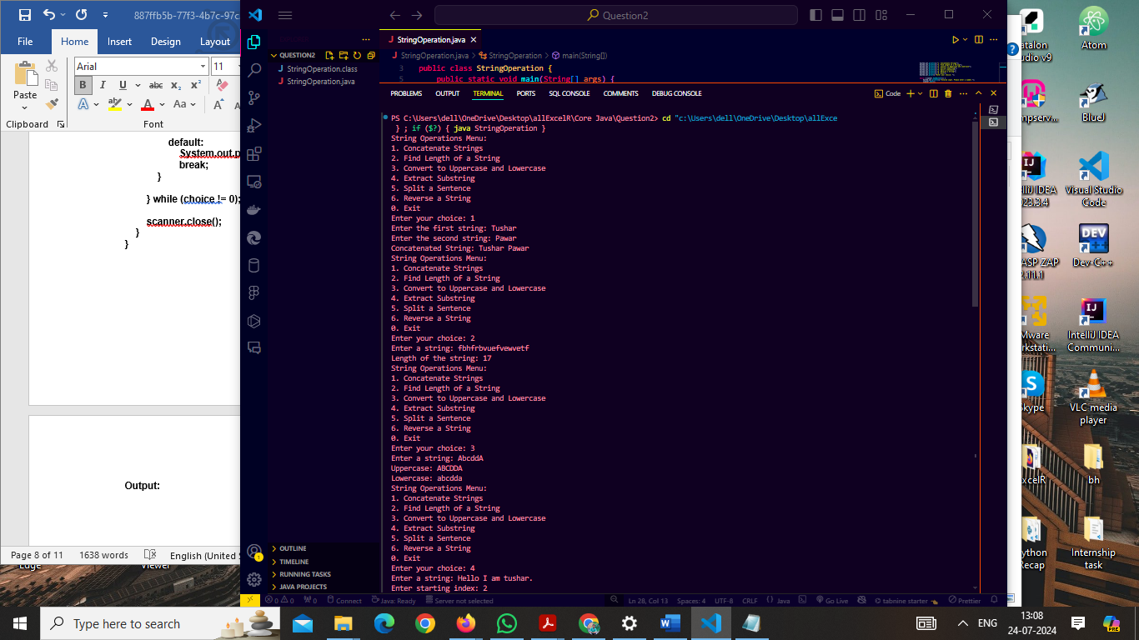

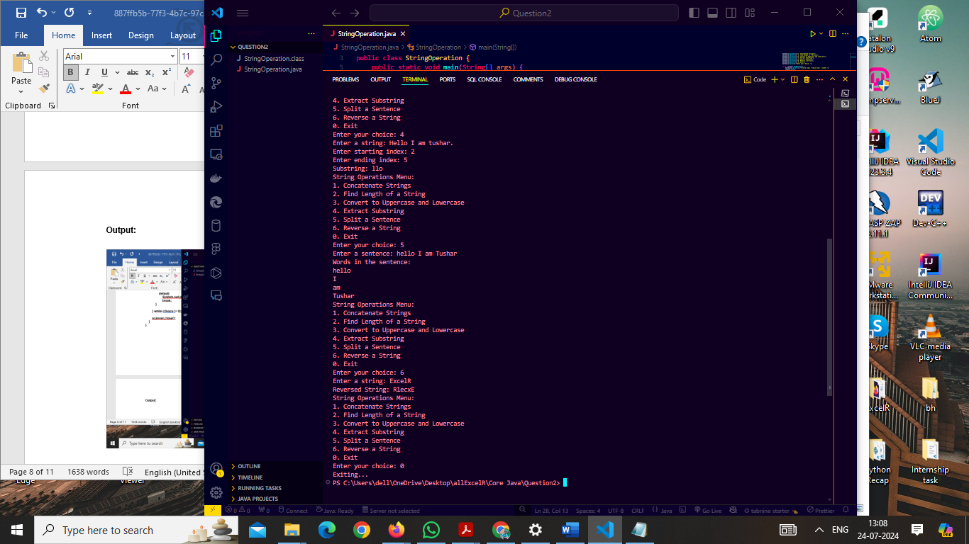

1. **Design a Java program to cover all File related topics, demonstrating various File operations in Java. The program should allow users to perform the following tasks:**
   1. **Create a new directory.**
   2. **Create a new text file and write content to it.**
   3. **Read the content from an existing text file.**
   4. **Append new content to an existing text file.**
   5. **Copy the content from one text file to another.**
   6. **Delete a text file.**
   7. **List all files and directories in a given directory.**
   8. **Search for a specific file in a directory and its subdirectories.**
   9. **Rename a file.**
   10. **Get information about a file (e.g., file size, last modified time).**
   11. **Requirements:**
       1. **Use File Input and Output streams for reading and writing text files.**
       2. **Implement exception handling to handle possible errors during file operations.**
       3. **Provide a user-friendly console interface for the user to interact with the program.**

**Code :**

**import java.io.*;**

**import java.nio.file.*;**

**import java.text.SimpleDateFormat;**

**import java.util.Date;**

**import java.util.Scanner;**

**public class FileOperations {**

**public static void main(String[] args) {**

**Scanner scanner = new Scanner(System.in);**

**int choice;**

**do {**

**System.out.println("File Operations Menu:");**

**System.out.println("1. Create a new directory");**

**System.out.println("2. Create a new text file and write content to it");**

**System.out.println("3. Read content from an existing text file");**

**System.out.println("4. Append new content to an existing text file");**

**System.out.println("5. Copy content from one text file to another");**

**System.out.println("6. Delete a text file");**

**System.out.println("7. List all files and directories in a given directory");**

**System.out.println("8. Search for a specific file in a directory and its subdirectories");**

**System.out.println("9. Rename a file");**

**System.out.println("10. Get information about a file");**

**System.out.println("0. Exit");**

**System.out.print("Enter your choice: ");**

**while (!scanner.hasNextInt()) {**

**System.out.println("Invalid input. Please enter a number.");**

**scanner.next();**

**System.out.print("Enter your choice: ");**

**}**

**choice = scanner.nextInt();**

**scanner.nextLine();**

**switch (choice) {**

**case 1:**

**System.out.print("Enter the directory path: ");**

**String dirPath = scanner.nextLine();**

**File dir = new File(dirPath);**

**if (dir.mkdirs()) {**

**System.out.println("Directory created successfully.");**

**} else {**

**System.out.println("Failed to create directory or directory already exists.");**

**}**

**break;**

**case 2:**

**System.out.print("Enter the file path: ");**

**String filePath = scanner.nextLine();**

**System.out.print("Enter content to write to the file: ");**

**String content = scanner.nextLine();**

**try (BufferedWriter writer = new BufferedWriter(new FileWriter(filePath))) {**

**writer.write(content);**

**System.out.println("Content written to file successfully.");**

**} catch (IOException e) {**

**System.out.println("An error occurred while writing to the file: " + e.getMessage());**

**}**

**break;**

**case 3:**

**System.out.print("Enter the file path: ");**

**String readFilePath = scanner.nextLine();**

**try (BufferedReader reader = new BufferedReader(new FileReader(readFilePath))) {**

**String line;**

**while ((line = reader.readLine()) != null) {**

**System.out.println(line);**

**}**

**} catch (IOException e) {**

**System.out.println("An error occurred while reading the file: " + e.getMessage());**

**}**

**break;**

**case 4:**

**System.out.print("Enter the file path: ");**

**String appendFilePath = scanner.nextLine();**

**System.out.print("Enter content to append: ");**

**String appendContent = scanner.nextLine();**

**try (BufferedWriter writer = new BufferedWriter(new FileWriter(appendFilePath, true))) {**

**writer.write(appendContent);**

**System.out.println("Content appended to file successfully.");**

**} catch (IOException e) {**

**System.out.println("An error occurred while appending to the file: " + e.getMessage());**

**}**

**break;**

**case 5:**

**System.out.print("Enter the source file path: ");**

**String sourceFilePath = scanner.nextLine();**

**System.out.print("Enter the destination file path: ");**

**String destFilePath = scanner.nextLine();**

**try {**

**Files.copy(Paths.get(sourceFilePath), Paths.get(destFilePath), StandardCopyOption.REPLACE_EXISTING);**

**System.out.println("File copied successfully.");**

**} catch (IOException e) {**

**System.out.println("An error occurred while copying the file: " + e.getMessage());**

**}**

**break;**

**case 6:**

**System.out.print("Enter the file path: ");**

**String deleteFilePath = scanner.nextLine();**

**File fileToDelete = new File(deleteFilePath);**

**if (fileToDelete.delete()) {**

**System.out.println("File deleted successfully.");**

**} else {**

**System.out.println("Failed to delete the file or file does not exist.");**

**}**

**break;**

**case 7:**

**System.out.print("Enter the directory path: ");**

**String listDirPath = scanner.nextLine();**

**File listDir = new File(listDirPath);**

**if (listDir.isDirectory()) {**

**File[] files = listDir.listFiles();**

**if (files != null) {**

**for (File file : files) {**

**System.out.println((file.isDirectory() ? "Directory: " : "File: ") + file.getName());**

**}**

**} else {**

**System.out.println("No files found in the directory.");**

**}**

**} else {**

**System.out.println("The specified path is not a directory.");**

**}**

**break;**

**case 8:**

**System.out.print("Enter the directory path: ");**

**String searchDirPath = scanner.nextLine();**

**System.out.print("Enter the file name to search for: ");**

**String fileName = scanner.nextLine();**

**searchFile(new File(searchDirPath), fileName);**

**break;**

**case 9:**

**System.out.print("Enter the current file path: ");**

**String oldFilePath = scanner.nextLine();**

**System.out.print("Enter the new file path: ");**

**String newFilePath = scanner.nextLine();**

**File oldFile = new File(oldFilePath);**

**File newFile = new File(newFilePath);**

**if (oldFile.renameTo(newFile)) {**

**System.out.println("File renamed successfully.");**

**} else {**

**System.out.println("Failed to rename the file or file does not exist.");**

**}**

**break;**

**case 10:**

**System.out.print("Enter the file path: ");**

**String infoFilePath = scanner.nextLine();**

**File infoFile = new File(infoFilePath);**

**if (infoFile.exists()) {**

**System.out.println("File Size: " + infoFile.length() + " bytes");**

**SimpleDateFormat sdf = new SimpleDateFormat("MM/dd/yyyy HH:mm:ss");**

**System.out.println("Last Modified: " + sdf.format(new Date(infoFile.lastModified())));**

**} else {**

**System.out.println("File does not exist.");**

**}**

**break;**

**case 0:**

**System.out.println("Exiting...");**

**break;**

**default:**

**System.out.println("Invalid choice. Please try again.");**

**break;**

**}**

**} while (choice != 0);**

**scanner.close();**

**}**

**private static void searchFile(File directory, String fileName) {**

**File[] files = directory.listFiles();**

**if (files != null) {**

**for (File file : files) {**

**if (file.isDirectory()) {**

**searchFile(file, fileName);**

**} else if (file.getName().equalsIgnoreCase(fileName)) {**

**System.out.println("File found: " + file.getAbsolutePath());**

**}**

**}**

**}**

**}**

**}**

**Output:**

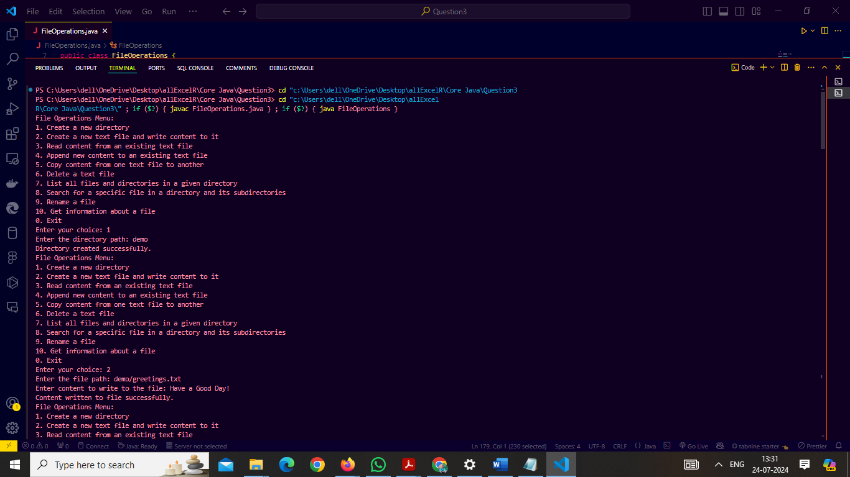

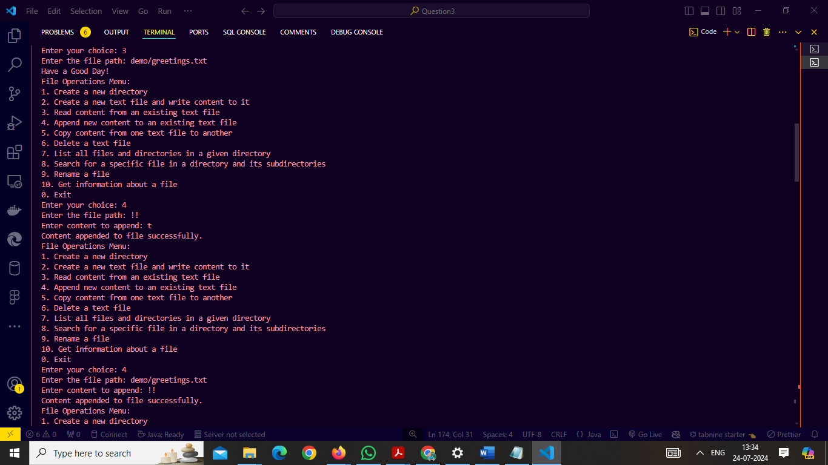

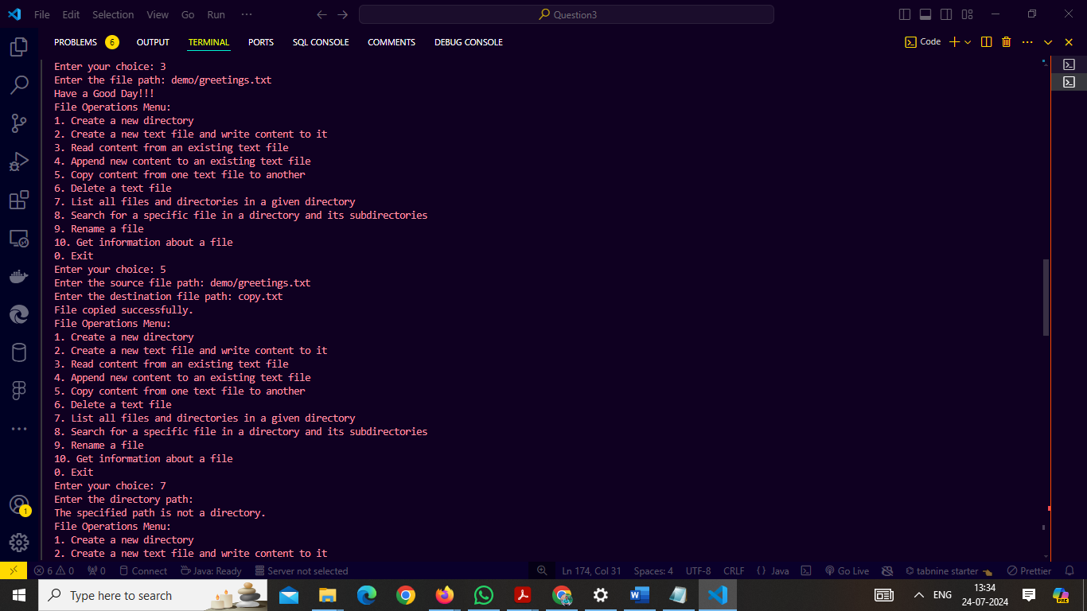

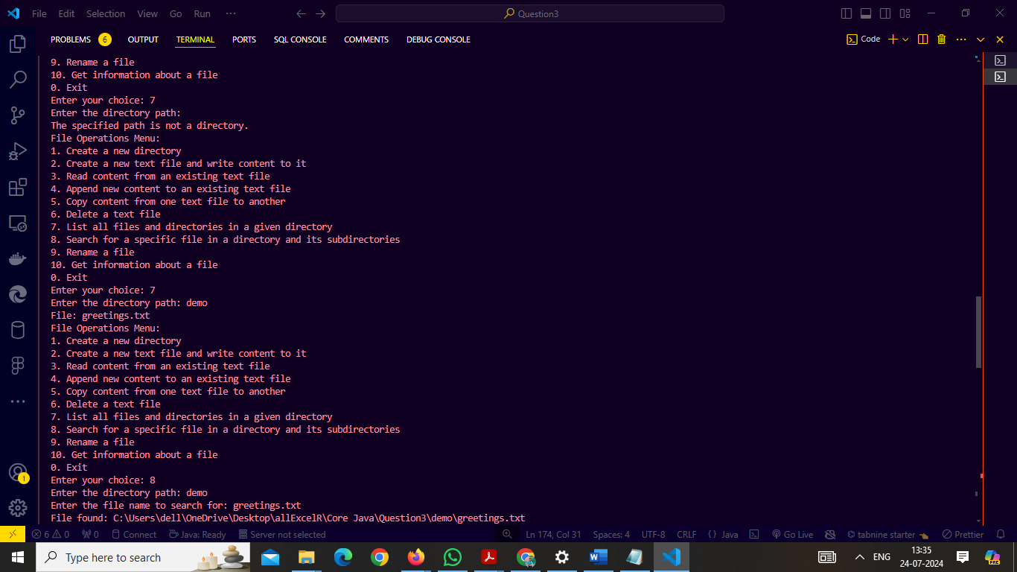

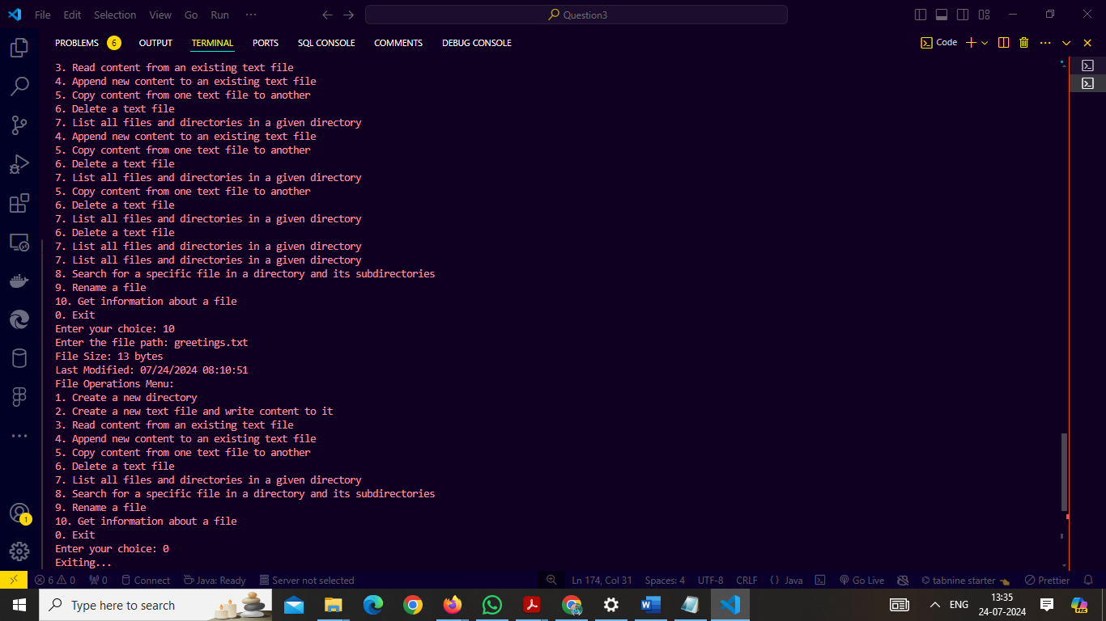

1. **Design a Java program that covers all thread-related topics, demonstrating various multithreading concepts in Java. The program should allow users to perform the following tasks:**
   1. **Create and start multiple threads.**
   2. **Synchronize threads to avoid race conditions and ensure data consistency.**
   3. **Use wait() and notify() to implement thread communication.**
   4. **Use sleep() to pause threads for a specified duration.**
   5. **Demonstrate thread interruption and thread termination.**
   6. **Use thread pools to manage a group of threads efficiently.**
   7. **Implement thread synchronization using locks and conditions.**
   8. **Demonstrate deadlock and ways to avoid it.**
   9. **Use thread-local variables to handle thread-specific data.**
   10. **Implement producer-consumer problem using thread synchronization.**
   11. **Use Executors and Callable to perform parallel computation and get results.**
   12. **Requirements:**
       1. **Implement exception handling to handle possible errors during multithreaded operations.**
       2. **Provide a user-friendly console interface for the user to interact with the program.**

**Code :**

import java.util.concurrent.*;

import java.util.concurrent.locks.*;

import java.util.*;

public class ThreadDemo {

private static final int NUM_THREADS = 3;

private static final int PRODUCER_COUNT = 1;

private static final int CONSUMER_COUNT = 2;

private static final BlockingQueue<Integer> queue = new LinkedBlockingQueue<>();

private static final Lock lock = new ReentrantLock();

private static final Condition condition = lock.newCondition();

private static final ThreadLocal<Integer> threadLocalValue = ThreadLocal.withInitial(() -> 0);

public static void main(String[] args) {

Scanner scanner = new Scanner(System.in);

int choice;

do {

System.out.println("Thread Operations Menu:");

System.out.println("1. Create and start multiple threads");

System.out.println("2. Synchronize threads");

System.out.println("3. Use wait() and notify()");

System.out.println("4. Use sleep() to pause threads");

System.out.println("5. Demonstrate thread interruption and termination");

System.out.println("6. Use thread pools");

System.out.println("7. Implement thread synchronization using locks and conditions");

System.out.println("8. Demonstrate deadlock and ways to avoid it");

System.out.println("9. Use thread-local variables");

System.out.println("10. Implement producer-consumer problem");

System.out.println("11. Use Executors and Callable");

System.out.println("0. Exit");

System.out.print("Enter your choice: ");

while (!scanner.hasNextInt()) {

System.out.println("Invalid input. Please enter a number.");

scanner.next();

System.out.print("Enter your choice: ");

}

choice = scanner.nextInt();

scanner.nextLine();

switch (choice) {

case 1:

System.out.println("Creating and starting threads...");

List<Thread> threads = new ArrayList<>();

for (int i = 0; i < NUM_THREADS; i++) {

Thread thread = new Thread(new RunnableTask("Thread-" + i));

threads.add(thread);

thread.start();

}

for (Thread thread : threads) {

try {

thread.join();

} catch (InterruptedException e) {

System.out.println("Thread interrupted: " + e.getMessage());

}

}

break;

case 2:

System.out.println("Synchronizing threads...");

Thread syncThread1 = new Thread(new SyncTask());

Thread syncThread2 = new Thread(new SyncTask());

syncThread1.start();

syncThread2.start();

try {

syncThread1.join();

syncThread2.join();

} catch (InterruptedException e) {

System.out.println("Thread interrupted: " + e.getMessage());

}

break;

case 3:

System.out.println("Demonstrating wait() and notify()...");

ThreadWaitNotify twn = new ThreadWaitNotify();

Thread consumerThread = new Thread(() -> twn.consumer());

Thread producerThread = new Thread(() -> twn.producer());

consumerThread.start();

producerThread.start();

try {

consumerThread.join();

producerThread.join();

} catch (InterruptedException e) {

System.out.println("Thread interrupted: " + e.getMessage());

}

break;

case 4:

System.out.println("Demonstrating sleep()...");

Thread sleepThread = new Thread(() -> {

try {

Thread.sleep(2000);

System.out.println("Thread woke up after 2 seconds");

} catch (InterruptedException e) {

System.out.println("Thread interrupted: " + e.getMessage());

}

});

sleepThread.start();

try {

sleepThread.join();

} catch (InterruptedException e) {

System.out.println("Thread interrupted: " + e.getMessage());

}

break;

case 5:

System.out.println("Demonstrating thread interruption...");

ThreadInterrupt demo = new ThreadInterrupt();

Thread interruptThread = new Thread(demo);

interruptThread.start();

try {

Thread.sleep(1000);

interruptThread.interrupt();

interruptThread.join();

} catch (InterruptedException e) {

System.out.println("Main thread interrupted: " + e.getMessage());

}

break;

case 6:

System.out.println("Using thread pools...");

ExecutorService executor = Executors.newFixedThreadPool(NUM_THREADS);

List<Future<?>> futures = new ArrayList<>();

for (int i = 0; i < NUM_THREADS; i++) {

final int taskId = i;

futures.add(executor.submit(() -> {

System.out.println("Task " + taskId + " running");

try {

Thread.sleep(2000);

} catch (InterruptedException e) {

System.out.println("Task " + taskId + " interrupted: " + e.getMessage());

}

}));

}

for (Future<?> future : futures) {

try {

future.get();

} catch (InterruptedException | ExecutionException e) {

System.out.println("Error in task: " + e.getMessage());

}

}

executor.shutdown();

break;

case 7:

System.out.println("Demonstrating locks and conditions...");

Thread lockThread1 = new Thread(new LockConditionTask());

Thread lockThread2 = new Thread(new LockConditionTask());

lockThread1.start();

lockThread2.start();

try {

lockThread1.join();

lockThread2.join();

} catch (InterruptedException e) {

System.out.println("Thread interrupted: " + e.getMessage());

}

break;

case 8:

System.out.println("Demonstrating deadlock...");

Thread deadlockThread1 = new Thread(new DeadlockTask(true));

Thread deadlockThread2 = new Thread(new DeadlockTask(false));

deadlockThread1.start();

deadlockThread2.start();

try {

deadlockThread1.join();

deadlockThread2.join();

} catch (InterruptedException e) {

System.out.println("Thread interrupted: " + e.getMessage());

}

break;

case 9:

System.out.println("Using thread-local variables...");

Thread threadLocalThread1 = new Thread(() -> {

threadLocalValue.set((int) (Math.random() * 100));

System.out.println("Thread-local value: " + threadLocalValue.get());

});

threadLocalThread1.start();

try {

threadLocalThread1.join();

} catch (InterruptedException e) {

System.out.println("Thread interrupted: " + e.getMessage());

}

break;

case 10:

System.out.println("Implementing producer-consumer problem...");

List<Thread> producerThreads = new ArrayList<>();

List<Thread> consumerThreads = new ArrayList<>();

for (int i = 0; i < PRODUCER_COUNT; i++) {

Thread producer = new Thread(new Producer());

producerThreads.add(producer);

producer.start();

}

for (int i = 0; i < CONSUMER_COUNT; i++) {

Thread consumer = new Thread(new Consumer());

consumerThreads.add(consumer);

consumer.start();

}

for (Thread producer : producerThreads) {

try {

producer.join();

} catch (InterruptedException e) {

System.out.println("Producer thread interrupted: " + e.getMessage());

}

}

for (Thread consumer : consumerThreads) {

try {

consumer.join();

} catch (InterruptedException e) {

System.out.println("Consumer thread interrupted: " + e.getMessage());

}

}

break;

case 11:

System.out.println("Using Executors and Callable...");

ExecutorService executorService = Executors.newFixedThreadPool(NUM_THREADS);

List<Future<Integer>> results = new ArrayList<>();

for (int i = 0; i < NUM_THREADS; i++) {

final int taskId = i;

results.add(executorService.submit(() -> {

System.out.println("Callable task " + taskId + " running");

Thread.sleep(2000);

return taskId * 2;

}));

}

for (Future<Integer> future : results) {

try {

System.out.println("Result: " + future.get());

} catch (InterruptedException | ExecutionException e) {

System.out.println("Error getting result: " + e.getMessage());

}

}

executorService.shutdown();

break;

case 0:

System.out.println("Exiting...");

break;

default:

System.out.println("Invalid choice. Please try again.");

break;

}

} while (choice != 0);

scanner.close();

}

static class RunnableTask implements Runnable {

private final String name;

public RunnableTask(String name) {

this.name = name;

}

@Override

public void run() {

System.out.println(name + " is running.");

}

}

// Synchronization Task

static class SyncTask implements Runnable {

private static int count = 0;

private static final Object lock = new Object();

@Override

public void run() {

synchronized (lock) {

count++;

System.out.println("Count: " + count);

}

}

}

// Wait and Notify Task

static class ThreadWaitNotify {

private boolean flag = false;

public synchronized void producer() {

System.out.println("Producer started");

try {

Thread.sleep(1000);

flag = true;

notify();

System.out.println("Producer finished");

} catch (InterruptedException e) {

e.printStackTrace();

}

}

public synchronized void consumer() {

System.out.println("Consumer started");

while (!flag) {

try {

wait();

} catch (InterruptedException e) {

e.printStackTrace();

}

}

System.out.println("Consumer finished");

}

}

// Interrupt Task

static class ThreadInterrupt implements Runnable {

@Override

public void run() {

try {

while (!Thread.currentThread().isInterrupted()) {

System.out.println("Running...");

Thread.sleep(500);

}

} catch (InterruptedException e) {

System.out.println("Thread was interrupted!");

}

}

}

// Locks and Conditions Task

static class LockConditionTask implements Runnable {

@Override

public void run() {

lock.lock();

try {

System.out.println("Thread is waiting...");

condition.await();

System.out.println("Thread is resuming...");

} catch (InterruptedException e) {

System.out.println("Thread interrupted: " + e.getMessage());

} finally {

lock.unlock();

}

}

}

// Deadlock Task

static class DeadlockTask implements Runnable {

private final boolean flag;

private static final Object lock1 = new Object();

private static final Object lock2 = new Object();

public DeadlockTask(boolean flag) {

this.flag = flag;

}

@Override

public void run() {

if (flag) {

synchronized (lock1) {

System.out.println("Lock 1 acquired by " + Thread.currentThread().getName());

try {

Thread.sleep(100);

} catch (InterruptedException e) {

e.printStackTrace();

}

synchronized (lock2) {

System.out.println("Lock 2 acquired by " + Thread.currentThread().getName());

}

}

} else {

synchronized (lock2) {

System.out.println("Lock 2 acquired by " + Thread.currentThread().getName());

try {

Thread.sleep(100);

} catch (InterruptedException e) {

e.printStackTrace();

}

synchronized (lock1) {

System.out.println("Lock 1 acquired by " + Thread.currentThread().getName());

}

}

}

}

}

// Producer-Consumer Problem

static class Producer implements Runnable {

@Override

public void run() {

for (int i = 0; i < 5; i++) {

try {

queue.put(i);

System.out.println("Produced: " + i);

Thread.sleep(1000);

} catch (InterruptedException e) {

System.out.println("Producer interrupted: " + e.getMessage());

}

}

}

}

static class Consumer implements Runnable {

@Override

public void run() {

while (true) {

try {

Integer item = queue.take();

System.out.println("Consumed: " + item);

} catch (InterruptedException e) {

System.out.println("Consumer interrupted: " + e.getMessage());

}

}

}

}

}

**Output :**

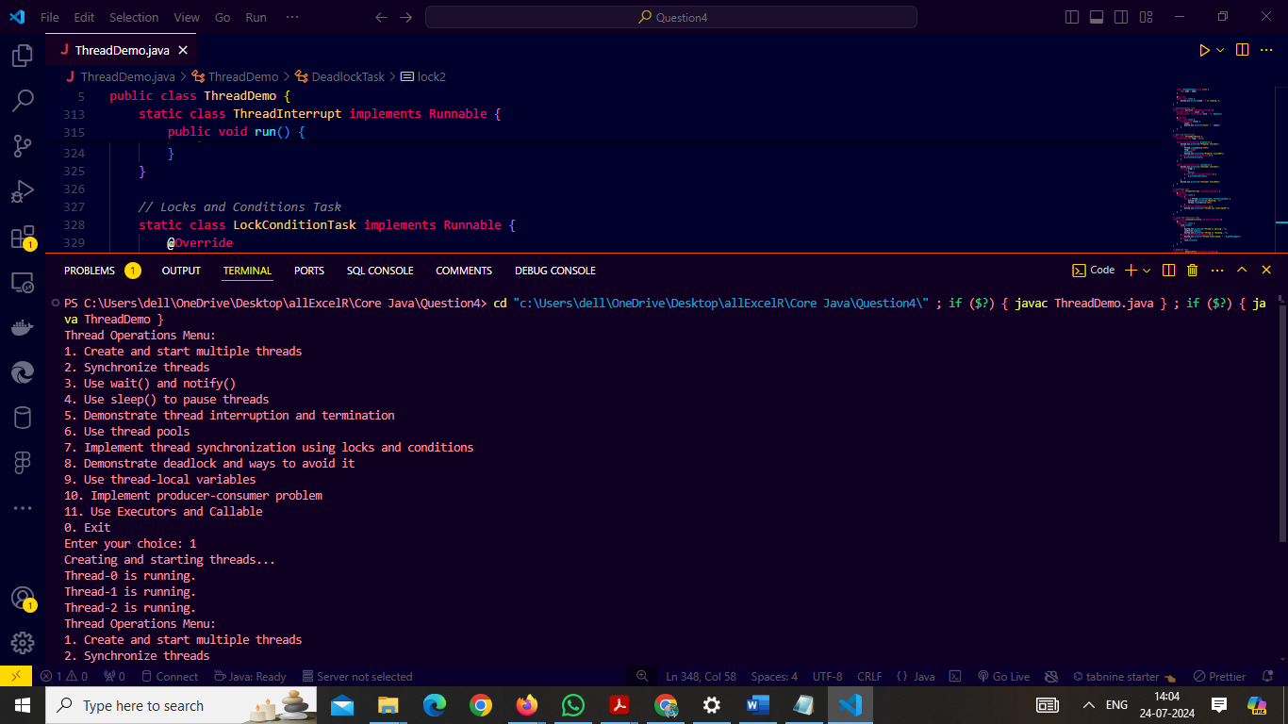

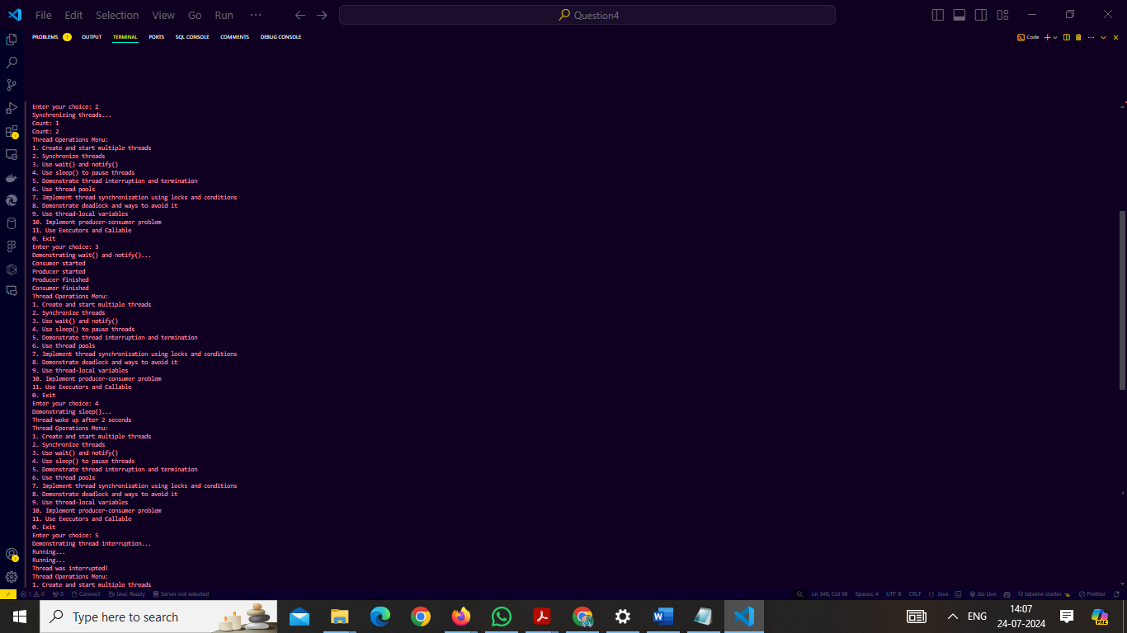

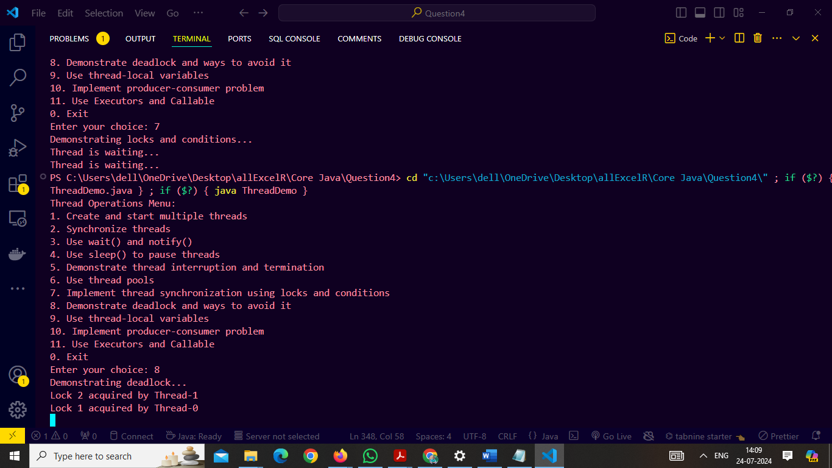

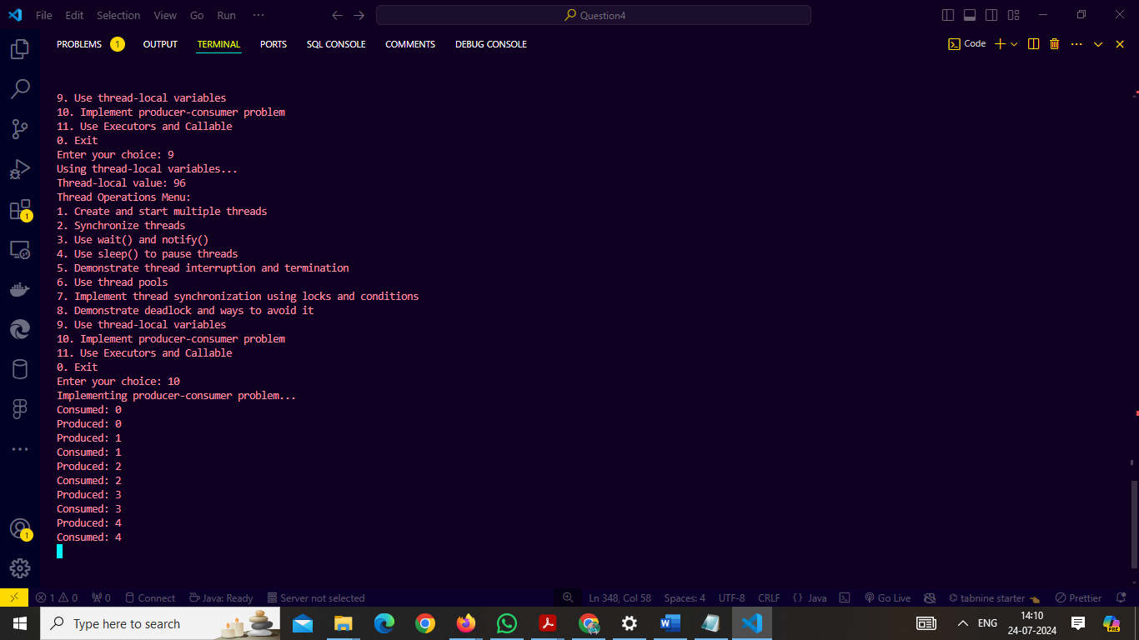

1. **Design a Java program to implement a Collection Management System that manages different types of collections such as lists, sets, and maps. The program should allow users to perform the following operations for each type of collection:**
   1. **Lists:**
      1. **Add an element: The user can add an element to the list.**
      2. **Remove an element: The user can remove an element from the list.**
      3. **Display all elements: The user can view all elements in the list.**
   2. **Sets:**
      1. **Add an element: The user can add an element to the set.**
      2. **Remove an element: The user can remove an element from the set.**
      3. **Display all elements: The user can view all elements in the set.**
   3. **Maps:**
      1. **Add a key-value pair: The user can add a key-value pair to the map.**
      2. **Remove a key-value pair: The user can remove a key-value pair from the map.**
      3. **Display all key-value pairs: The user can view all key-value pairs in the map.**
   4. **Requirements:**
      1. **Implement separate classes for each type of collection (ListManager, SetManager, MapManager).**
      2. **Use appropriate collection classes (e.g., ArrayList, LinkedList, HashSet, TreeMap) to store the elements and key-value pairs.**
      3. **Use inheritance and polymorphism to manage different types of collections.**
      4. **Implement exception handling to handle possible errors (e.g., element not found in the list/set, duplicate keys in the map).**
      5. **Provide a user-friendly console interface for the user to interact with the Collection Management System.**

**e)Cover all Java collections topics, including Lists, Sets, and Maps**

**code:**

**import java.util.*;**

**import java.util.Scanner;**

**abstract class CollectionManager {**

**abstract void addElement();**

**abstract void removeElement();**

**abstract void displayElements();**

**}**

**class ListManager extends CollectionManager {**

**private List<String> list = new ArrayList<>();**

**private Scanner scanner = new Scanner(System.in);**

**@Override**

**void addElement() {**

**System.out.print("Enter element to add to the list: ");**

**String element = scanner.nextLine();**

**list.add(element);**

**System.out.println("Element added.");**

**}**

**@Override**

**void removeElement() {**

**System.out.print("Enter element to remove from the list: ");**

**String element = scanner.nextLine();**

**if (list.remove(element)) {**

**System.out.println("Element removed.");**

**} else {**

**System.out.println("Element not found.");**

**}**

**}**

**@Override**

**void displayElements() {**

**System.out.println("List elements: " + list);**

**}**

**}**

**class SetManager extends CollectionManager {**

**private Set<String> set = new HashSet<>();**

**private Scanner scanner = new Scanner(System.in);**

**@Override**

**void addElement() {**

**System.out.print("Enter element to add to the set: ");**

**String element = scanner.nextLine();**

**if (set.add(element)) {**

**System.out.println("Element added.");**

**} else {**

**System.out.println("Element already exists.");**

**}**

**}**

**@Override**

**void removeElement() {**

**System.out.print("Enter element to remove from the set: ");**

**String element = scanner.nextLine();**

**if (set.remove(element)) {**

**System.out.println("Element removed.");**

**} else {**

**System.out.println("Element not found.");**

**}**

**}**

**@Override**

**void displayElements() {**

**System.out.println("Set elements: " + set);**

**}**

**}**

**class MapManager extends CollectionManager {**

**private Map<String, String> map = new TreeMap<>();**

**private Scanner scanner = new Scanner(System.in);**

**@Override**

**void addElement() {**

**System.out.print("Enter key: ");**

**String key = scanner.nextLine();**

**System.out.print("Enter value: ");**

**String value = scanner.nextLine();**

**if (map.containsKey(key)) {**

**System.out.println("Key already exists. Updating value.");**

**}**

**map.put(key, value);**

**System.out.println("Key-Value pair added.");**

**}**

**@Override**

**void removeElement() {**

**System.out.print("Enter key to remove from the map: ");**

**String key = scanner.nextLine();**

**if (map.remove(key) != null) {**

**System.out.println("Key-Value pair removed.");**

**} else {**

**System.out.println("Key not found.");**

**}**

**}**

**@Override**

**void displayElements() {**

**System.out.println("Map elements: " + map);**

**}**

**}**

**public class Main {**

**public static void main(String[] args) {**

**Scanner scanner = new Scanner(System.in);**

**CollectionManager listManager = new ListManager();**

**CollectionManager setManager = new SetManager();**

**CollectionManager mapManager = new MapManager();**

**int choice;**

**do {**

**System.out.println("Collection Management System:");**

**System.out.println("1. Manage Lists");**

**System.out.println("2. Manage Sets");**

**System.out.println("3. Manage Maps");**

**System.out.println("0. Exit");**

**System.out.print("Enter your choice: ");**

**while (!scanner.hasNextInt()) {**

**System.out.println("Invalid input. Please enter a number.");**

**scanner.next();**

**System.out.print("Enter your choice: ");**

**}**

**choice = scanner.nextInt();**

**scanner.nextLine();**

**switch (choice) {**

**case 1:**

**manageCollection(listManager);**

**break;**

**case 2:**

**manageCollection(setManager);**

**break;**

**case 3:**

**manageCollection(mapManager);**

**break;**

**case 0:**

**System.out.println("Exiting...");**

**break;**

**default:**

**System.out.println("Invalid choice. Please try again.");**

**break;**

**}**

**} while (choice != 0);**

**scanner.close();**

**}**

**private static void manageCollection(CollectionManager manager) {**

**Scanner scanner = new Scanner(System.in);**

**int choice;**

**do {**

**System.out.println("Collection Management Menu:");**

**System.out.println("1. Add element ");**

**System.out.println("2. Remove element ");**

**System.out.println("3. Display elements ");**

**System.out.println("0. Back to main menu ");**

**System.out.print("Enter your choice: ");**

**while (!scanner.hasNextInt()) {**

**System.out.println("Invalid input. Please enter a number.");**

**scanner.next();**

**System.out.print("Enter your choice: ");**

**}**

**choice = scanner.nextInt();**

**scanner.nextLine();**

**switch (choice) {**

**case 1:**

**manager.addElement();**

**break;**

**case 2:**

**manager.removeElement();**

**break;**

**case 3:**

**manager.displayElements();**

**break;**

**case 0:**

**System.out.println("Returning to main menu...");**

**break;**

**default:**

**System.out.println("Invalid choice. Please try again.");**

**break;**

**}**

**} while (choice != 0);**

**}**

**}**

**Output:**

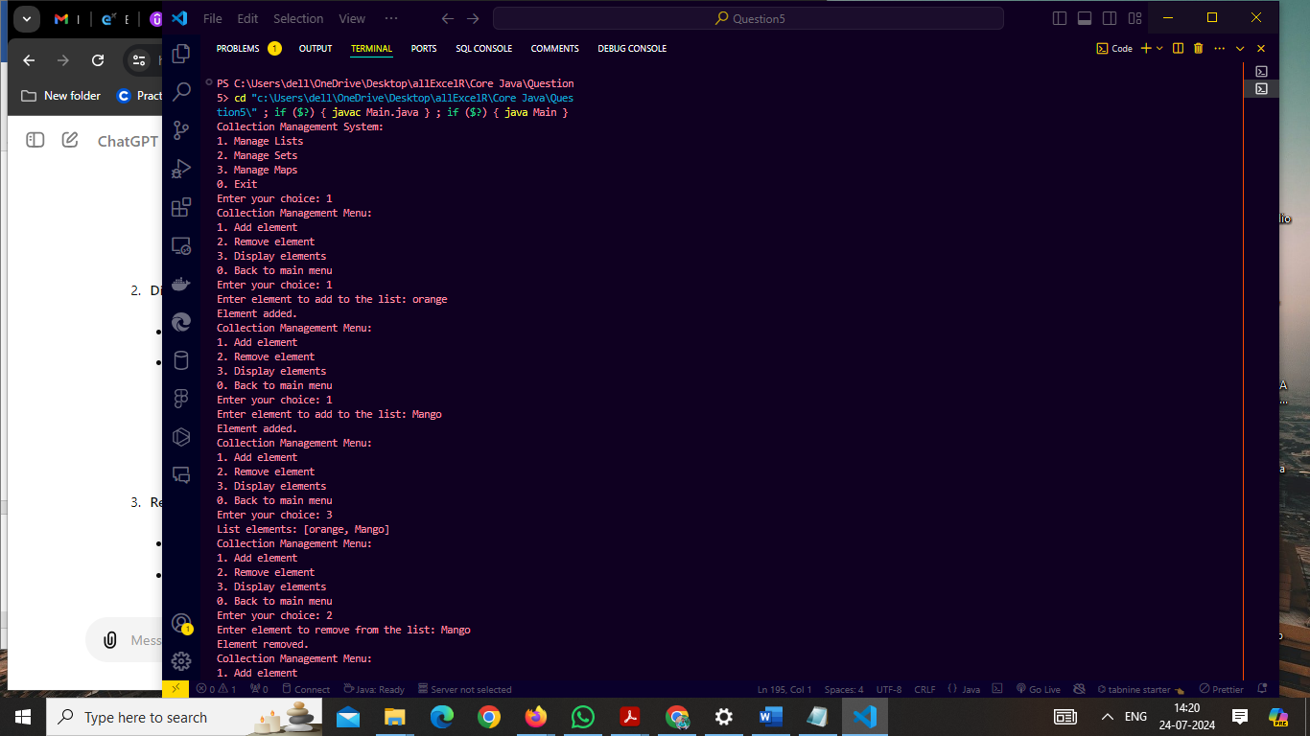

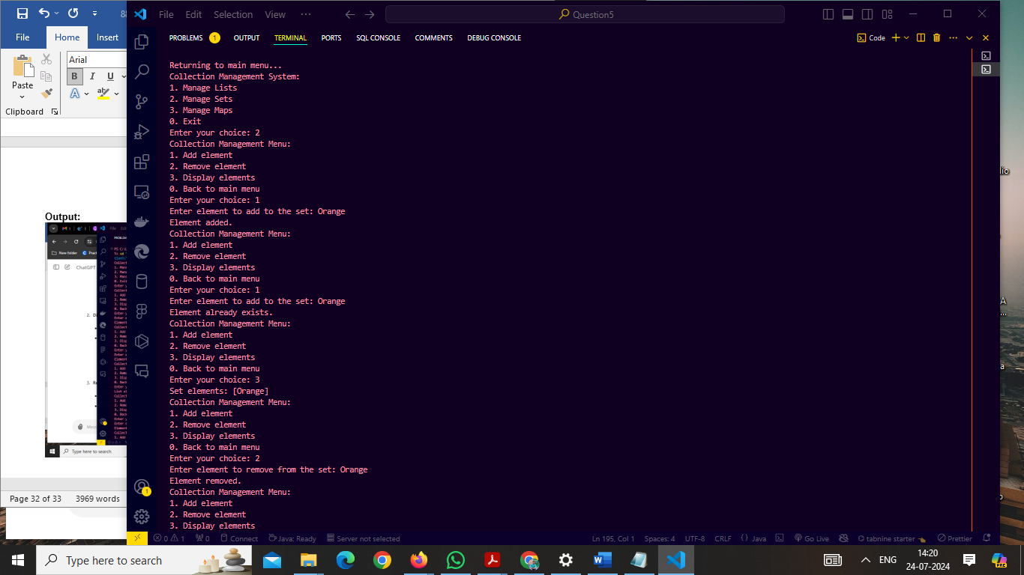

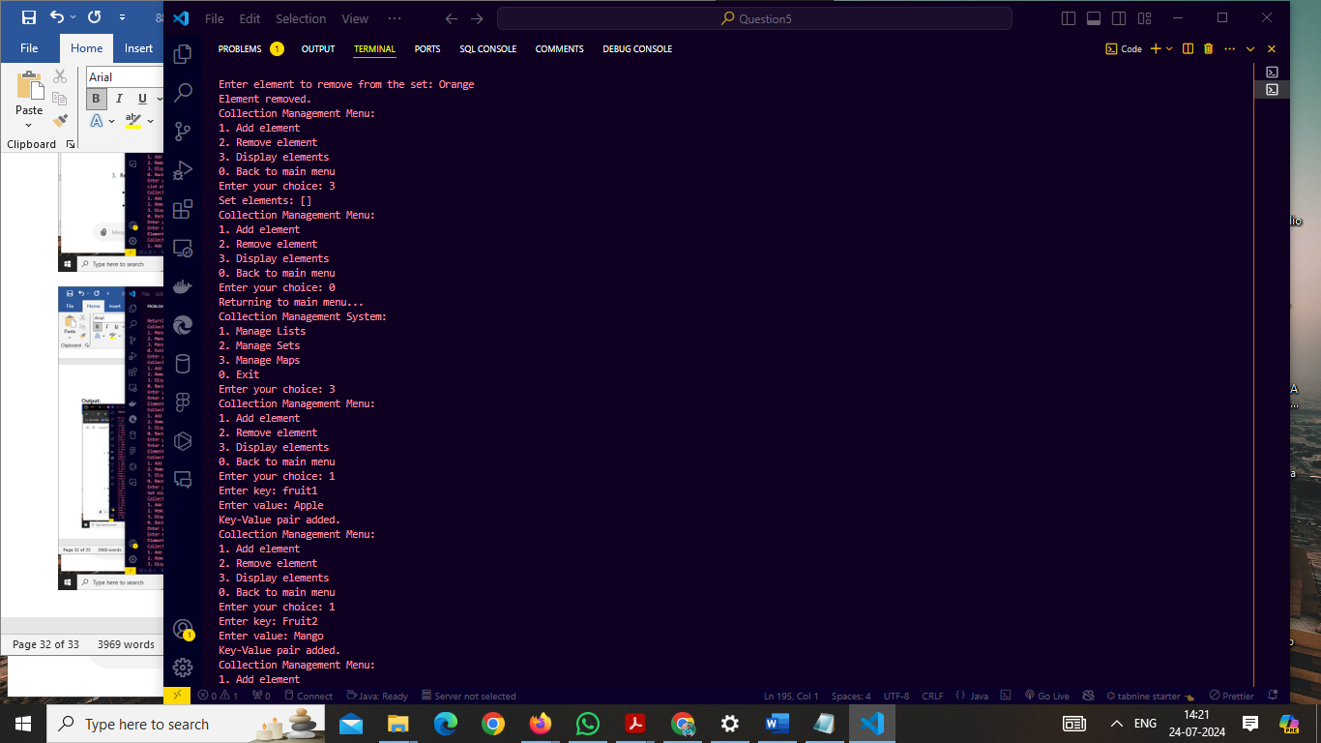

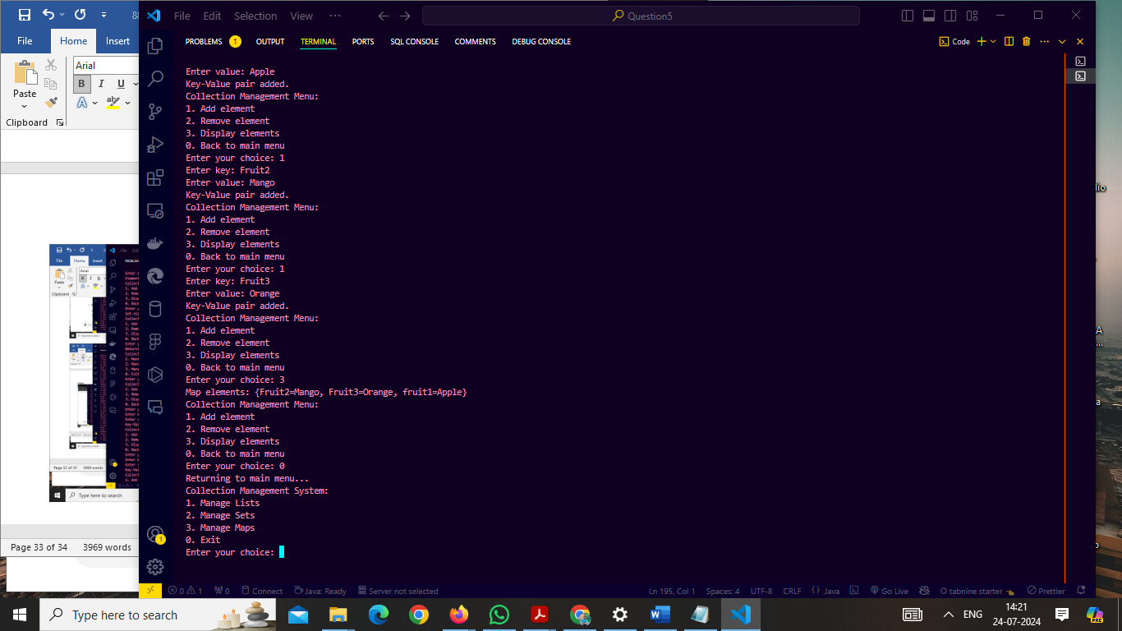

1. **Add new employees: The user can add details like employee ID, name, department, and salary.**
   1. **Update employee details: The user can update the name, department, or salary of an existing employee based on their employee ID.**
   2. **Delete an employee: The user can delete an employee from the system based on their employee ID.**
   3. **Display all employees: The user can view a list of all employees and their details.**
   4. **Search for an employee: The user can search for an employee by their employee ID and view their details.**
   5. **Requirements:**
      1. **Use Object-Oriented Programming (OOP) principles and create an Employee class with appropriate attributes and methods.**
      2. **Use appropriate data structures (e.g., ArrayList, HashMap) to store the employee data.**
      3. **Implement exception handling to handle possible errors (e.g., invalid employee ID, input validation).**
      4. **Provide a user-friendly console interface for the user to interact with the Employee Management System.**

**Code:**

import java.util.HashMap;

import java.util.Map;

import java.util.Scanner;

class Employee {

private String id;

private String name;

private String department;

private double salary;

public Employee(String id, String name, String department, double salary) {

this.id = id;

this.name = name;

this.department = department;

this.salary = salary;

}

public String getId() {

return id;

}

public String getName() {

return name;

}

public void setName(String name) {

this.name = name;

}

public String getDepartment() {

return department;

}

public void setDepartment(String department) {

this.department = department;

}

public double getSalary() {

return salary;

}

public void setSalary(double salary) {

this.salary = salary;

}

@Override

public String toString() {

return "ID: " + id + ", Name: " + name + ", Department: " + department + ", Salary: $" + salary;

}

}

class EmployeeManager {

private Map<String, Employee> employeeMap = new HashMap<>();

private Scanner scanner = new Scanner(System.in);

public void addEmployee() {

System.out.print("Enter Employee ID: ");

String id = scanner.nextLine();

if (employeeMap.containsKey(id)) {

System.out.println("Employee ID already exists.");

return;

}

System.out.print("Enter Employee Name: ");

String name = scanner.nextLine();

System.out.print("Enter Department: ");

String department = scanner.nextLine();

System.out.print("Enter Salary: ");

double salary = scanner.nextDouble();

scanner.nextLine();

Employee employee = new Employee(id, name, department, salary);

employeeMap.put(id, employee);

System.out.println("Employee added.");

}

public void updateEmployee() {

System.out.print("Enter Employee ID to update: ");

String id = scanner.nextLine();

Employee employee = employeeMap.get(id);

if (employee == null) {

System.out.println("Employee not found.");

return;

}

System.out.print("Enter new Name (leave blank to keep current): ");

String name = scanner.nextLine();

if (!name.isEmpty()) {

employee.setName(name);

}

System.out.print("Enter new Department (leave blank to keep current): ");

String department = scanner.nextLine();

if (!department.isEmpty()) {

employee.setDepartment(department);

}

System.out.print("Enter new Salary (leave blank to keep current): ");

String salaryInput = scanner.nextLine();

if (!salaryInput.isEmpty()) {

try {

double salary = Double.parseDouble(salaryInput);

employee.setSalary(salary);

} catch (NumberFormatException e) {

System.out.println("Invalid salary input.");

}

}

System.out.println("Employee details updated.");

}

public void deleteEmployee() {

System.out.print("Enter Employee ID to delete: ");

String id = scanner.nextLine();

if (employeeMap.remove(id) != null) {

System.out.println("Employee deleted.");

} else {

System.out.println("Employee not found.");

}

}

public void displayAllEmployees() {

if (employeeMap.isEmpty()) {

System.out.println("No employees to display.");

} else {

for (Employee employee : employeeMap.values()) {

System.out.println(employee);

}

}

}

public void searchEmployee() {

System.out.print("Enter Employee ID to search: ");

String id = scanner.nextLine();

Employee employee = employeeMap.get(id);

if (employee != null) {

System.out.println(employee);

} else {

System.out.println("Employee not found.");

}

}

}

public class Main {

public static void main(String[] args) {

EmployeeManager manager = new EmployeeManager();

Scanner scanner = new Scanner(System.in);

int choice;

do {

System.out.println("\nEmployee Management System:");

System.out.println("1. Add Employee");

System.out.println("2. Update Employee");

System.out.println("3. Delete Employee");

System.out.println("4. Display All Employees");

System.out.println("5. Search Employee");

System.out.println("0. Exit");

System.out.print("Enter your choice: ");

while (!scanner.hasNextInt()) {

System.out.println("Invalid input. Please enter a number.");

scanner.next();

System.out.print("Enter your choice: ");

}

choice = scanner.nextInt();

scanner.nextLine();

switch (choice) {

case 1:

manager.addEmployee();

break;

case 2:

manager.updateEmployee();

break;

case 3:

manager.deleteEmployee();

break;

case 4:

manager.displayAllEmployees();

break;

case 5:

manager.searchEmployee();

break;

case 0:

System.out.println("Exiting...");

break;

default:

System.out.println("Invalid choice. Please try again.");

break;

}

} while (choice != 0);

scanner.close();

}

}

**Output:**

